STACK.C

#include<stdio.h>

#include<conio.h>

int a[10],TOP=-1;

void push(int num)

{

if(TOP==9)

{

printf("Stack OverFlow\n");

}

else

{

TOP++;

a[TOP]=num;

}

}

void pop()

{

if(TOP==-1)

{

printf("Stack Underflow\n");

}

else

{

TOP--;

}

}

void display()

{

int i=TOP;

printf("The elements in the stack are:\n");

for(;i>=0;i--)

{

printf("%d ",a[i]);

}

}

void main()

{

int ch=0,num;

clrscr();

while(1)

{

printf("1-Push\t2-POP\t3-Display\t4-Exit");

printf("\nEnter choice = ");

scanf("%d",&ch);

if(ch==1)

{

printf("Enter number = ");

scanf("%d",&num);

push(num);

}

else if(ch==2)

{

pop();

}

else if(ch==3)

{

display();

}

else

{

exit(0);

}

printf("\n");

}

getch();

}

OUTPUT:

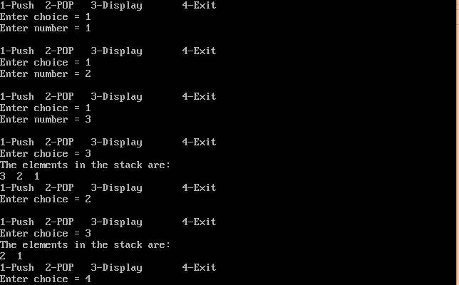

STACKLL.C

#include<stdio.h>

#include<conio.h>

#include<malloc.h>

typedef struct node

{

int data;

struct node \*next;

}stack;

stack \*TOP=NULL,\*temp,\*newnode;

void push(int num)

{

newnode =(stack\*) malloc(sizeof(stack));

newnode->data=num;

newnode->next=NULL;

if(TOP==NULL)

{

TOP=newnode;

}

else

{

newnode->next=TOP;

TOP=newnode;

}

}

void pop()

{

if(TOP==NULL)

printf("Stack is Empty\n");

else

{

temp=TOP;

TOP=temp->next;

free(temp);

}

}

void display()

{

if(TOP==NULL)

printf("Stack is Empty\n");

else

{

temp=TOP;

printf("The Elements are :\n");

while(temp!=NULL)

{

printf("%d->",temp->data);

temp=temp->next;

}

}

}

void main()

{

int ch,num;

clrscr();

while(1)

{

printf("\n1-Push\t2-POP\t3-Display\t4-Exit");

printf("\nEnter choice = ");

scanf("%d",&ch);

if(ch==1)

{

printf("Enter number = ");

scanf("%d",&num);

push(num);

}

else if(ch==2)

{

pop();

}

else if(ch==3)

{

display();

}

else

{

exit(0);

}

}

getch();

}

OUTPUT:

